Departamento de Educación
SIES WEB SERVICE

Documentación de Requerimientos y Configuración para
SIES Web Service

Versión 1.3

2 de noviembre de 2012

Control de Cambios

Date | Versión | Autor | Acción
3/25/2011 | 1.0 | Ramón Bermúdez | Creación del documento
3/31/2011 | 1.1 | Yolanda Rodríguez | Revisión del documento
9/16/2011 | 1.2 | Angel Ríos | Actualización propiedades de proceso automático
11/2/2011 | 1.3 | Abner García | Actualización de parámetros de configuración.

Tabla de Contenido

Control de Cambios 2
Software Dependency Requirements 4
Software Products 4
Server 4
Server Type: Web 4
Web Service: SIES 4
Web Service SIES - Web.Config 5
Web Service SIES – Host file information 5
Configuration Diagram 7
Database Job 8
Server Type: SQL Server 2008 R2 8
Import Process Configuration 9
SSIS Integration Package 9

Software Dependency Requirements

Software Products
Product Name | Version | License Consideration
Microsoft SQL Server 2008 R2 | 10.50.1600.1
Microsoft .NET Framework (English) | 4.0.30319 | Free Download | http://www.microsoft.com/downloads/en/details.aspx?displaylang=en&FamilyID=0a391abd-25c1-4fc0-919f-b21f31ab88b7
Internet Information Services (IIS) | 6 or later

Server

Server Type: Web
Server OS | Windows Server 2008 R2 w SP1
Server Name | DE-WEB-EE-001
Internet Information Services (IIS) | Ver. 7
Microsoft .NET Framework (English) | Ver. 4.0.30319 |  | http://www.microsoft.com/downloads/en/details.aspx?displaylang=en&FamilyID=0a391abd-25c1-4fc0-919f-b21f31ab88b7

Web Service: SIES
Web Site Name | SIEWS
Web Site Path | E:\Web Applications\SEIS\SIEWS\
IIS Authentication | - Anonymous Access  - Windows Authentication
IIS Directory Security | IP Address And Domain Name Restrictions  - Access for unspecified clients: Denied.  - Enable domain name restrictions.  - Granted:  - 127.0.0.1  - 192.168.22.245  - 192.168.22.233  - 192.168.102.172  - 192.168.22.181  - 192.168.22.164  - 192.168.22.75  - 192.168.22.176  - 192.168.23.78  - roc-ts.depr.net  - ocupaweb-tst-02.depr.net  - ocupaweb-tst-02  - de-webser-001  - de-web-ee-001.depr.net  - de-crm-001.depr.net  - de-web-ee-001  - de-crm-001  - localhost  - de-micenweb-001.depr.net  - de-micenweb-001

Web Service SIES - Web.Config
AlternateLookup | server=DE-SQL-EE-001;database=SIE;uid=sieuser;pwd=usersie;
PrimaryLookup | Data Source=PMAX1O;User Id=PRDE_WS;Password=PRDE_WS;Connection Timeout=15;
SieSecurity | Data Source=TMAX1O;User Id=PRDE_TMAXIO3;Password=PRDE_TMAXIO3;Connection Timeout=15;
SecondaryConnectFlagExpirationMinutes | 20
CipherKey | 1NT3LUT10N$

Web Service SIES – Host file information
Hosts | # SIE PMAXIO ADDRESSES  140.85.102.19 auohsmaxi24.oracleoutsourcing.com  140.85.102.20 auohsmaxi25.oracleoutsourcing.com  140.85.102.21 auohsmaxi26.oracleoutsourcing.com  140.85.102.22 auohsmaxi27.oracleoutsourcing.com  140.85.102.7 auohsmaxi66.oracleoutsourcing.com  140.85.102.8 auohsmaxi67.oracleoutsourcing.com  140.85.102.9 auohsmaxi68.oracleoutsourcing.com  140.85.102.10 auohsmaxi69.oracleoutsourcing.com

Configuration Diagram

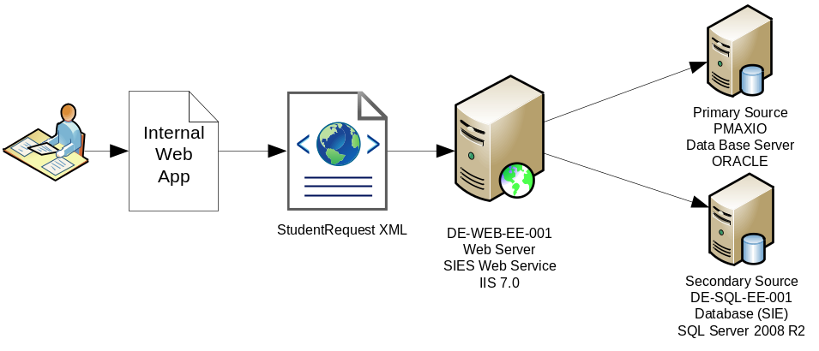

SIES Web Service database update process
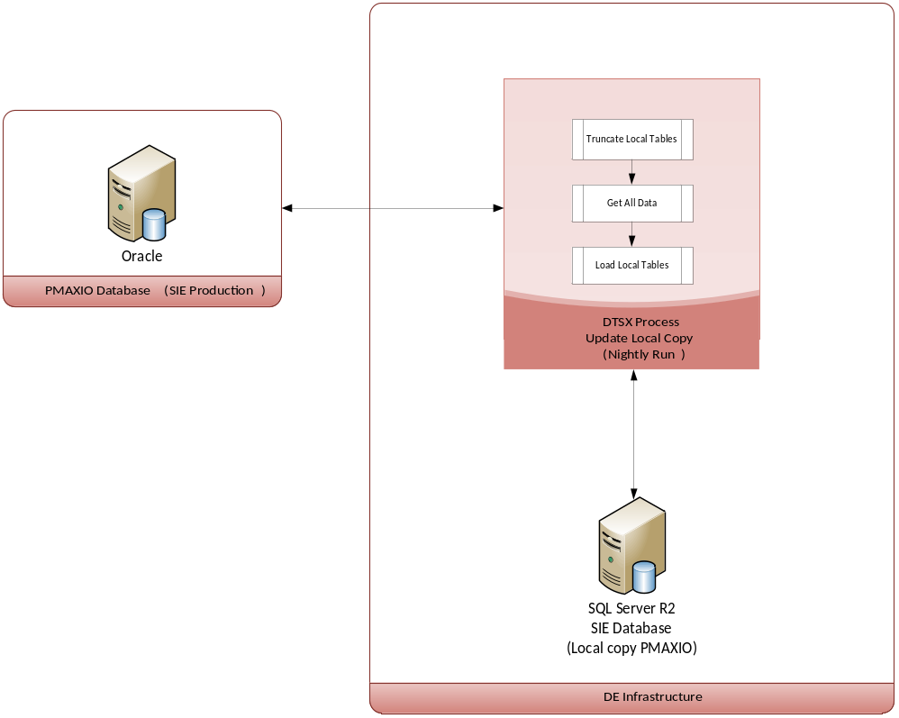

Database Job

Server Type: SQL Server 2008 R2
Server Name | DE-SQL-EE-001
Job Name | DE_SIE_VIEWS | Executes package in file path E:\ImportOracleData\IMPORT_MASTER.dtsx
Job Schedule | Daily at 6:00pm | NOTE: This job must be disabled during the End Of Year Process of the SIE System.
Job Duration | Around 5 hour 45 minutes to 6 hours 30 minutes. Depends on quantity of data and network load

Import Process Configuration

SSIS Integration Package
Server Name | DE-SQL-EE-001
Package Path Name | E:\ImportOracleData\IMPORT_MASTER.dtsx
Destination & Configuration DB Connection | E:\ImportOracleData\ImportOracleData.dtsConfig | Edit the connection string to the destination database. The process expects the table [admin.Configuration] to exist in the same database.
Admin.Configuration | Database table that holds the following configuration values
 | PMAXIO | Connection string for the source system database
 | SMTP | Connection to the SMTP server
 | VIEWSyncErrorMailTo | Email addresses of the person(s) that receive failure messages. Separated by semi-colon (;) no spaces
 | VIEWSyncErrorMailSubject | Subject of the error message
 | VIEWSyncErrorMailFrom | Dummy address of the sender
 | VIEWSyncErrorMsgBody | Free text of the error message. Serve as introduction. Error details are appended at the end of the body content.

